After you have signed in to CERS you will want to find your facility to begin the data entry or submittal process. In some cases your facility will have already been created by your local CUPA using data you previously provided them, or someone else in your business/organization may have previously created the facility. In either case, if your facility already exists in CERS, you just need to request access to the facility’s CERS business/organization before you can begin reporting on the facility.
If you are not sure if your facility/business is already in CERS, you can either follow the process shown below, or select the “Add New Facility” button as shown in #1 below. Either way, CERS will direct you on what you need to do based upon the facility information enter.
- Select the “Search” button under the “Request Access to an Existing CERS Business” section as shown below. Do not use the “Add a New Facility” section at this time.
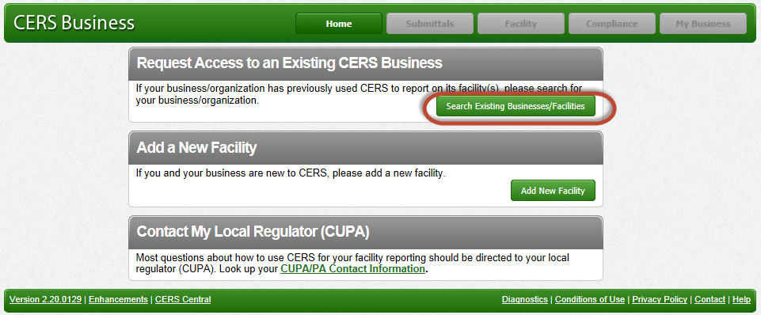

- Search for your facility by entering relevant data in one or a few of the fields shown in the search screen. In most cases, if you enter the Facility Address and either City and or ZIP fields will sufficiently narrow the search enough to easily find your facility. You could also enter the facility name, or a part of the facility name. For example, if your facility is called Acme Body Shop, you could type in ‘Acme’ and search.
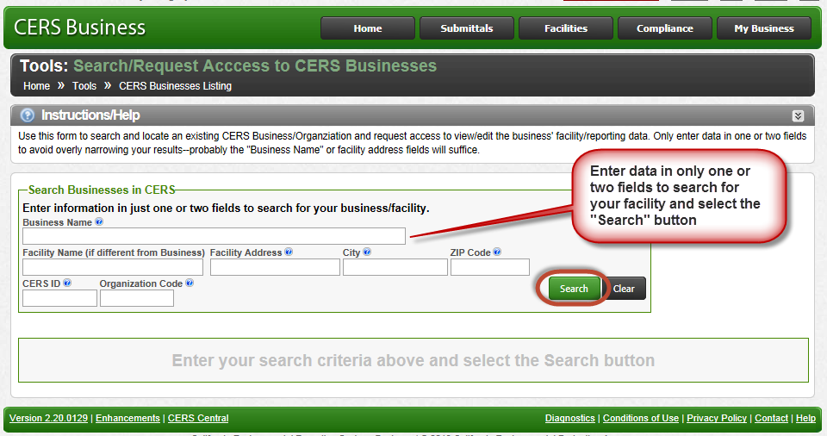
- Review your search results, and if your facility’s business is shown, select the “Request Access…” link. Now go to Requesting Access to an Existing Facility.
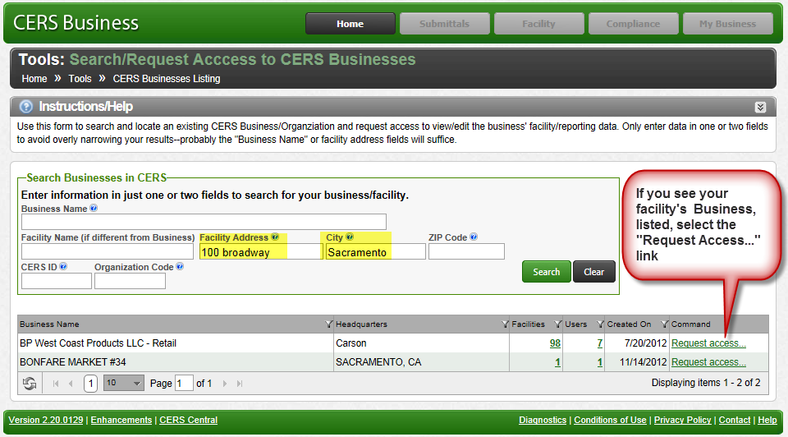
- If you are fairly sure your facility/business is already in CERS, try other search criteria to broaden your results. Try shortening your street address, e.g., use “1000 San Marino” instead of “1000 San Marino Blvd #2”. Also if your business or facility name includes punctuation (e.g., Bob’s Auto Body), try the search without the punctuation).
- If you do not find your business in CERS, then select the “Home” link at the top of the screen and select the “Add New Facility” button.
END

